# CS 255 System Design Document Template

## UML Diagrams

### UML Use Case Diagram

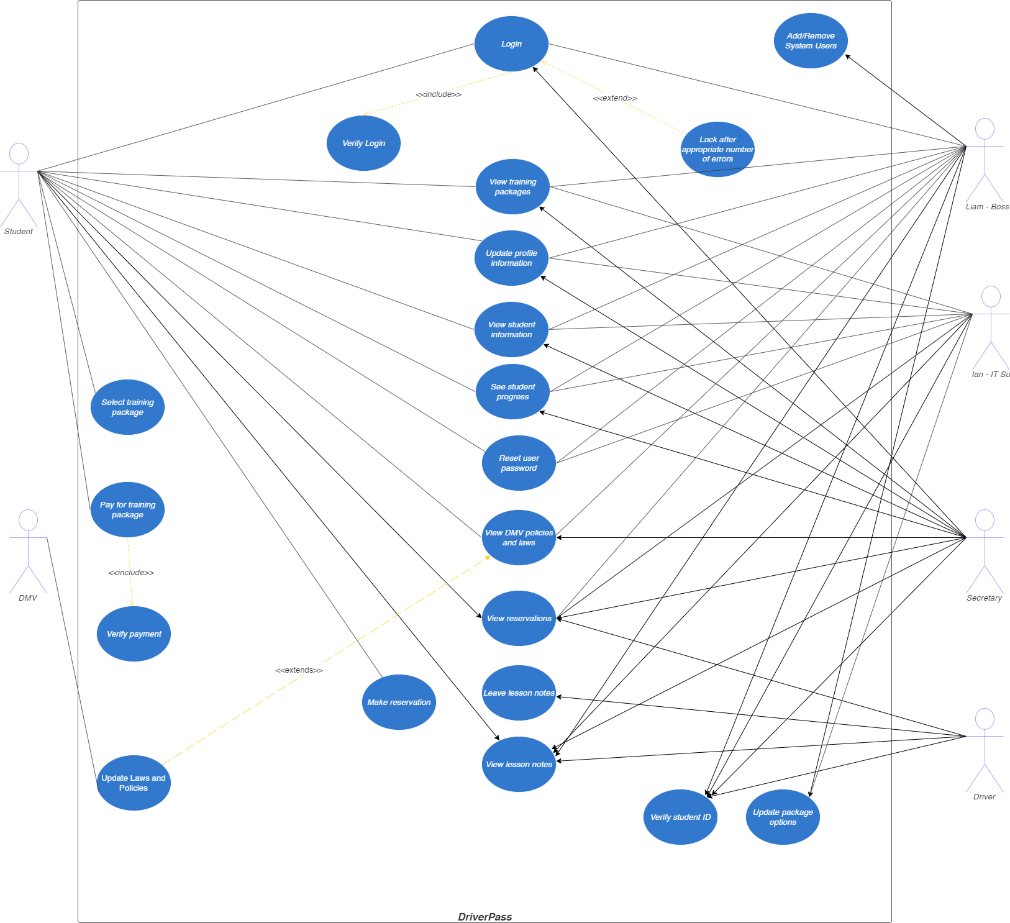

### UML Activity Diagrams

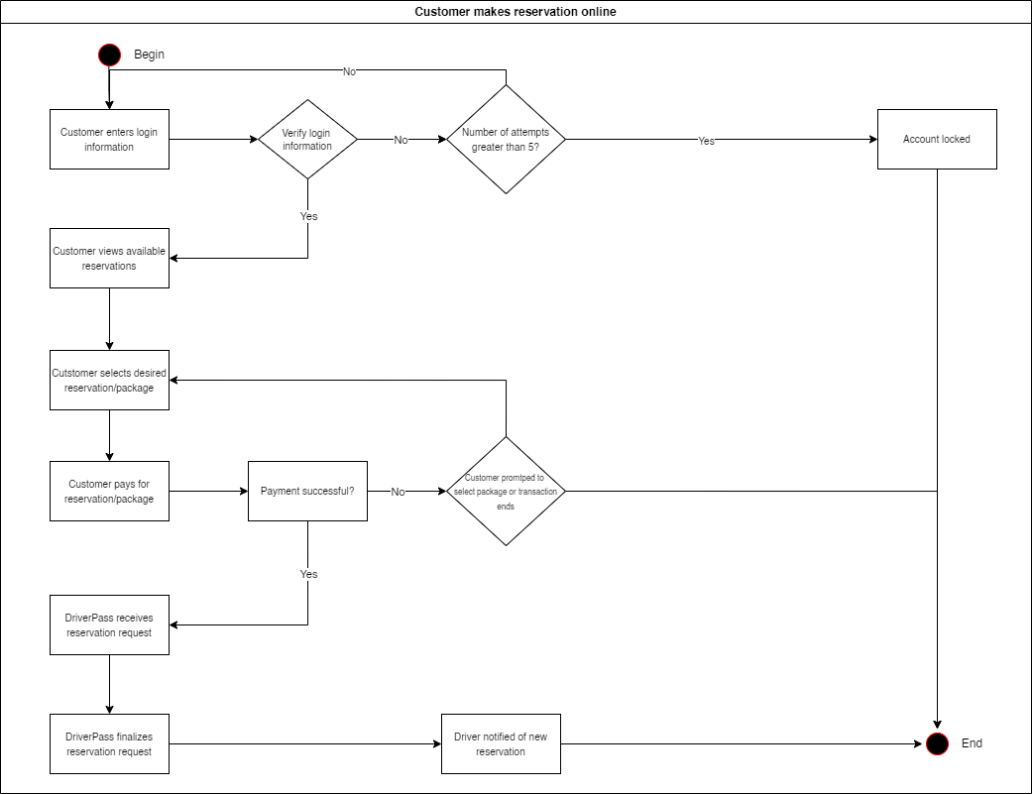

### UML Sequence Diagram

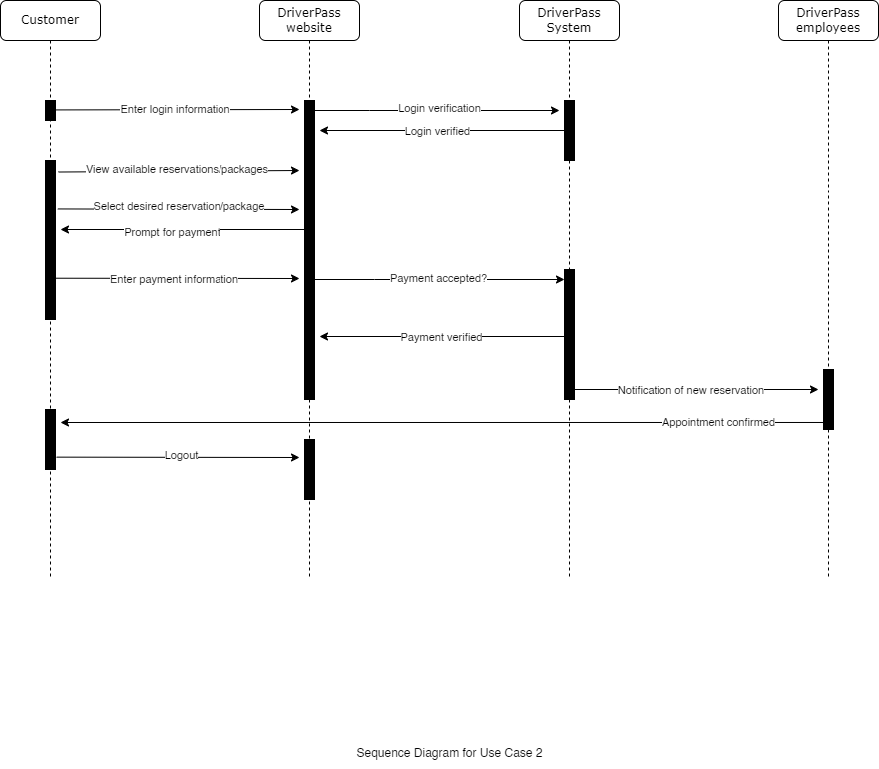

### UML Class Diagram

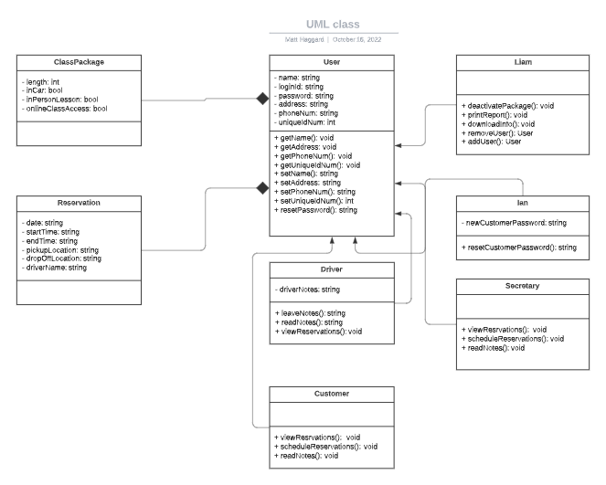

## Technical Requirements

*[Based on the diagrams you have created, describe the technical requirements of your system. These requirements should address the required hardware, software, tools, and infrastructure necessary for your system design.]*

The technical requirements from the hardware perspective should be fairly basic. Anyone with a device that has a supported web browser should be able to access the content. Obviously, the specs of the device will have a fair amount of influence on the experience, however, there will likely be a point of diminishing returns as the quality of the device improves. In other words, there is no need for the newest MacBook Pro or high-end gaming PC to run the software. A budget friendly option would likely work and give the user a good experience. On the flip side, a Samsung Galaxy S4 or iPhone 3G (provided they have access to a supported browser) would likely see a significant downgrade in experience over a Samsung Galaxy S20, iPhone X, or higher. The difference between a MacBook Air and a fairly up-to-date ThinkPad should not be significantly different though.

From a software perspective, there will need to be a database of some kind and a cloud storage option to store and organize data. A reliable internet connection is essential to do most everything on the website from account creation to appointment scheduling. TLS encryption will need to be implemented to ensure secure connection, so hosting the site on a server that is a Certificate Authority is a must. To interface with the website the user must have a supported browser running on some operating system. Linux, Windows, Mac OS, iOS, and Android are the most popular operating systems and it is likely the user will have access to at least one of them and some of the most popular browsers are Chrome, Edge, Firefox, Safari, Samsung Internet, Brave, and Opera, all of which are supported on at least some combination of the previously listed operating systems.